Maths
 | Maths Lesson Focus | Fluency Lesson Focus
Penguins EYFS | Year R White Rose Maths  Mastering Number | - Number bonds to 5  - Counting in 2s  - One more, one less
Pelican 1 | Year 1 White Rose Maths | - Number Bonds to 10 (end of year screening)  - 2 times tables  - 5 times tables  - 10 times tables
Parrots 2 | Year 2 White Rose Maths | - Number bonds to 100  - 3 times tables  - 4 times tables
Robins 3 | Year 3 White Rose Maths | - Doubling and halving numbers  - 8 times tables  - 9 times tables  - 11 times tables
Ravens 4 | Year 4 White Rose Maths | - 6 times tables  - 12 times tables  - 7 times tables  - Multiplication Check practice
Flamingos 5 | Year 5 White Rose Maths | - Times tables interventions where needed.  - 4 written operations.  - Adding and subtracting fractions.
Eagles 6 | Year 6 White Rose Maths  Stand alone arithmetic lesson 1 x weekly - SATs preparation. | - Times tables interventions where needed.  - 4 operations with fractions.  - Percentages.

Reception - White Rose Maths
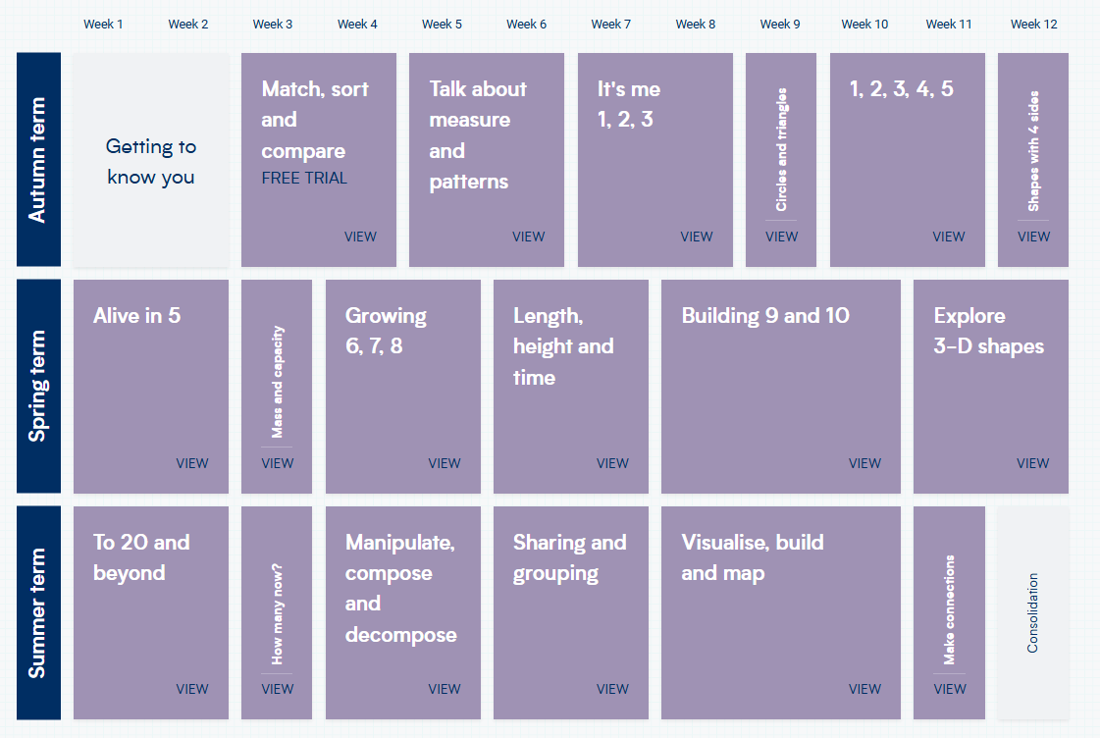
Reception - Mastering Number
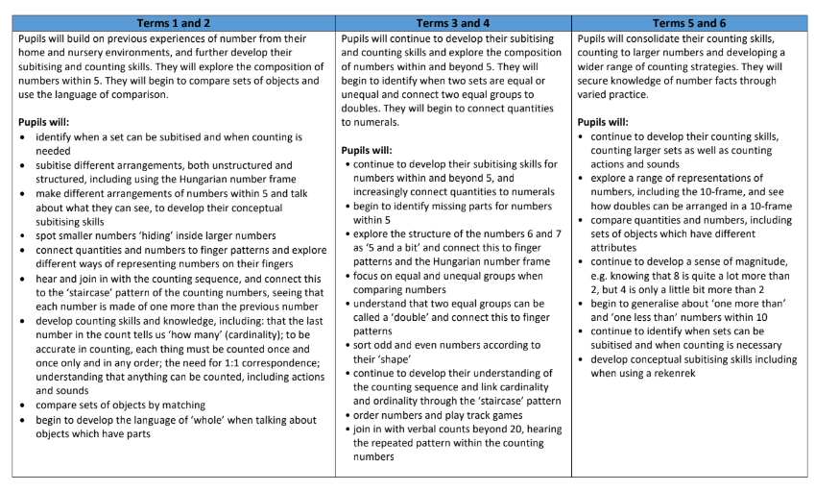

Year 1
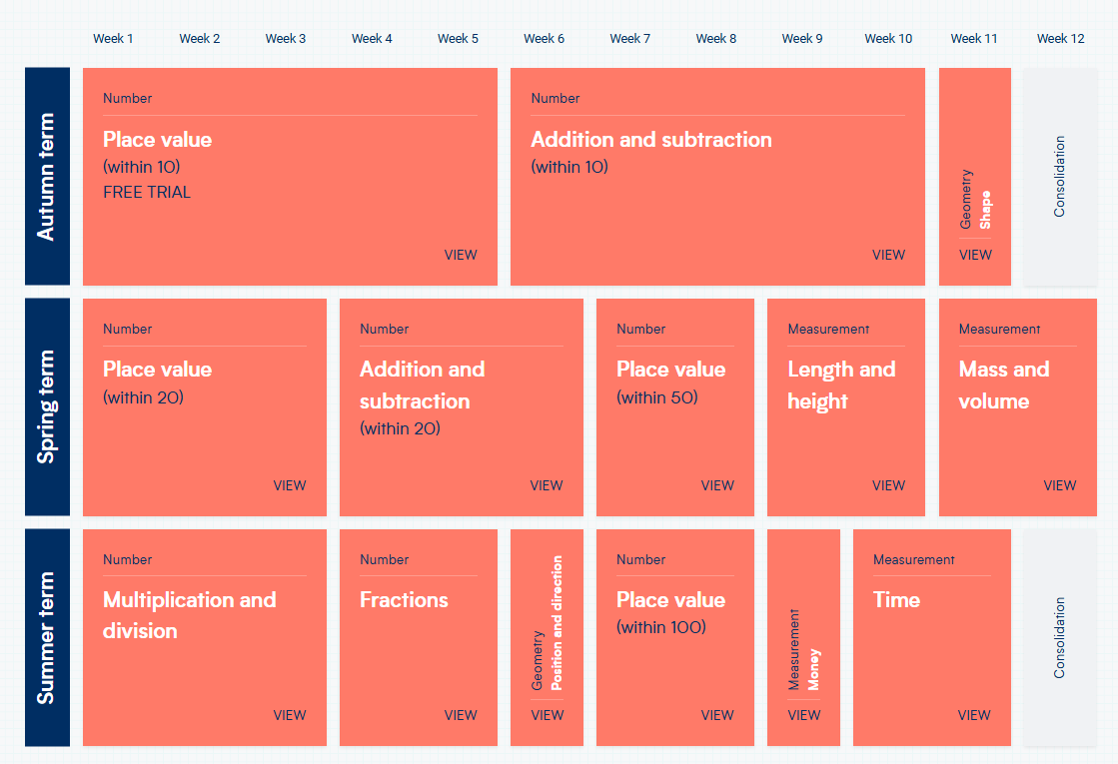
Year 2
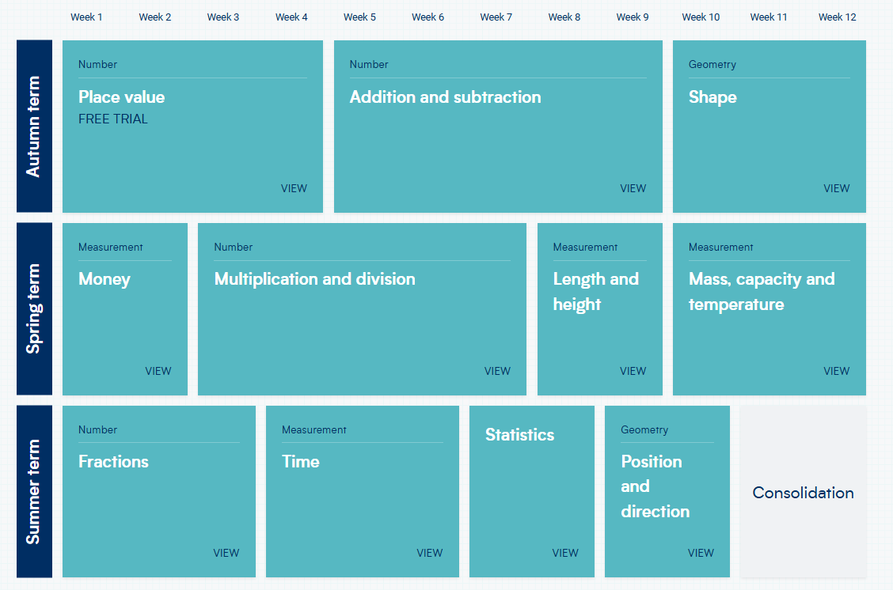
Year 3
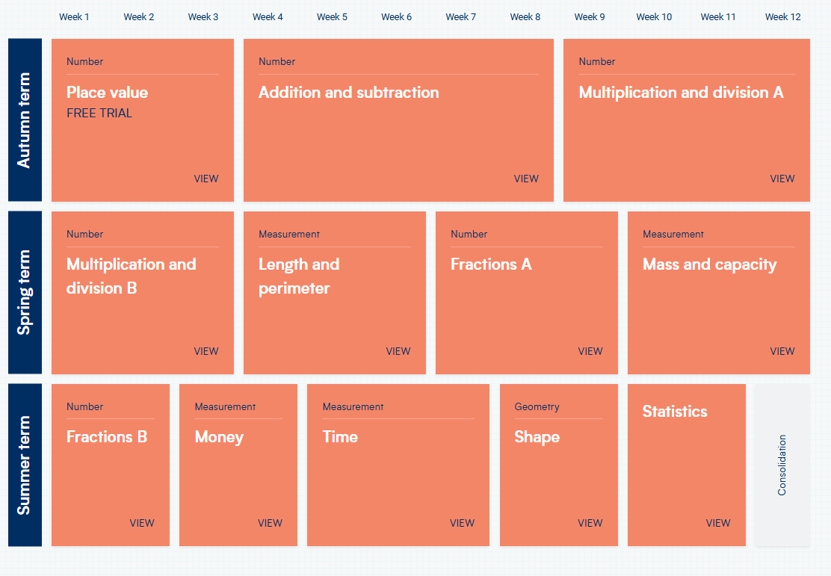
Year 4
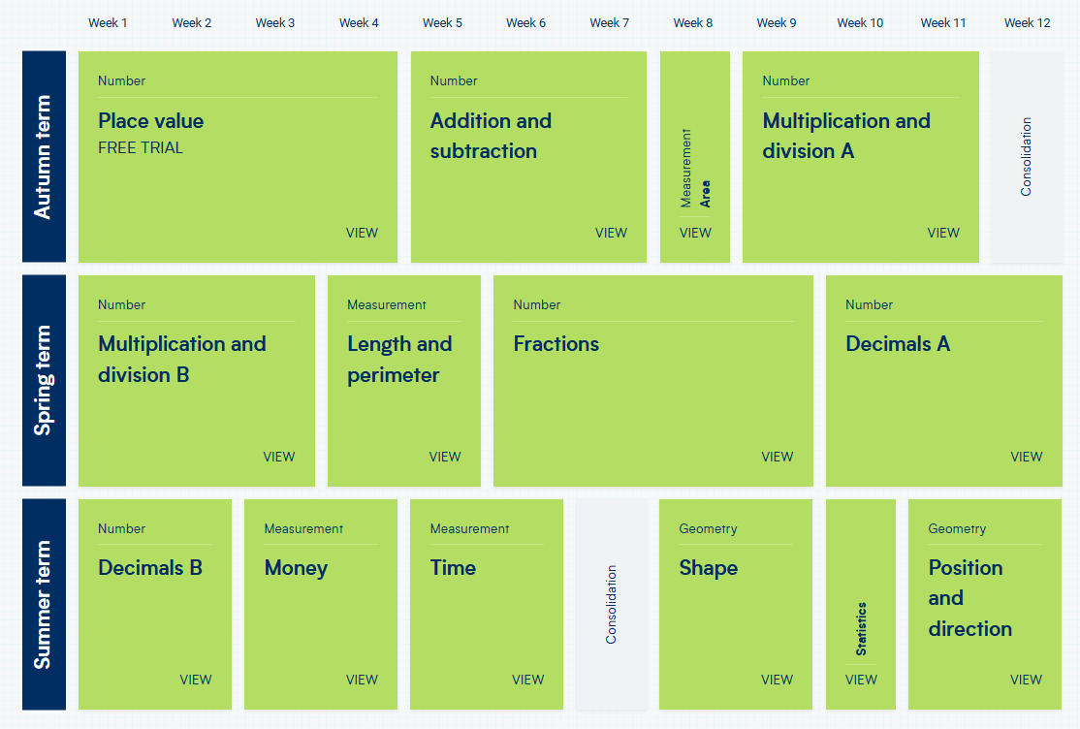
Year 5
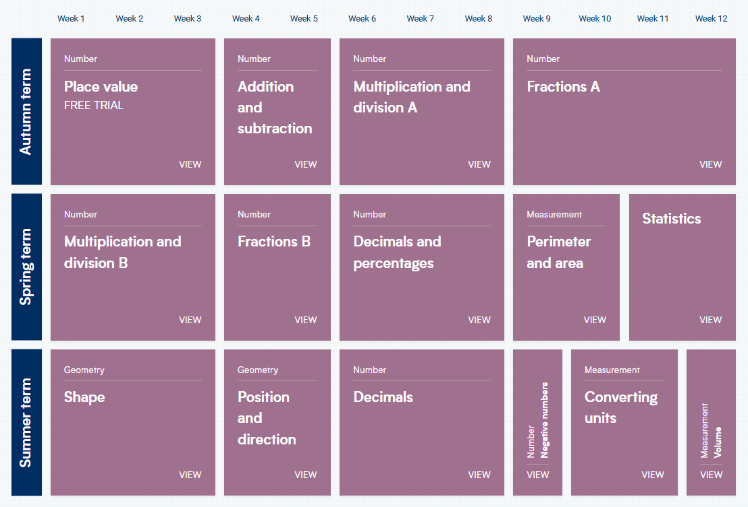
Year 6


